

**NATIONAL UNIVERSITY OF SCIENCE AND TECHNOLOGY (NUST)**

**School of Mechanical and Manufacturing Engineering (SMME)**

**Assignment # 02**

**Title:** Orthographic Projections

**Name:** Zahika Ihsan **CMS:** 461202

**Class:** AE-01 **Subject:** Engineering Drawing

**Subject Code:** AE-103 **Submission Date:** May 10th,2024.

**Semester:** 02  **Batch:** 2023

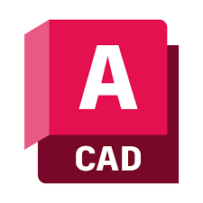

**OBJECTIVE:**

To understand the use of Orthographic Projections and to know how to draw isometric drawings as orthographic projections on Auto Cad.

**DEFINITIONS/ KEY CONCEPTS:**

1. **Orthographic Projections:**

Orthographic Projections is the way of drawing 3D objects on 2D plane. When the projectors are parallel to each other but perpendicular to the plane then the projection made are called orthographic projections.

1. **First Angle of Projection:**

In first angle of projection, the front view is placed on the top left, the top view is placed on bottom left and the left side view is placed on top right. Similarly, if we are seeing from left ide the left side view is placed on top right and the front and top views are placed on top right and bottom right.

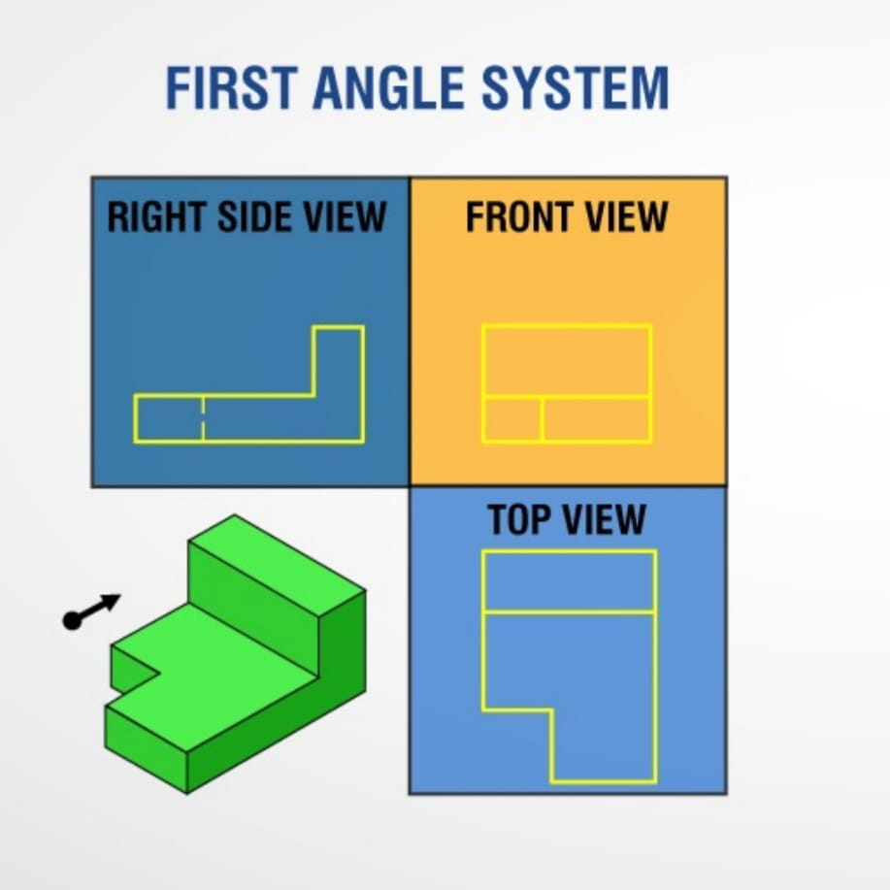

1. **Continuous Lines:**

A continuous line is a line that is used to make object outlines and visible things. Thin continuous lines are used for dimensions and hatch patterns on section views.

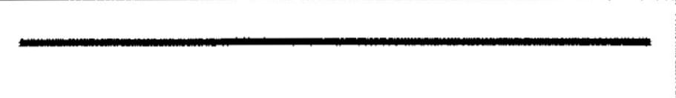

1. **Hidden Lines:**

A hidden line is a medium weight line, made of short dashes, used to show edges, surfaces and corners which cannot be seen.

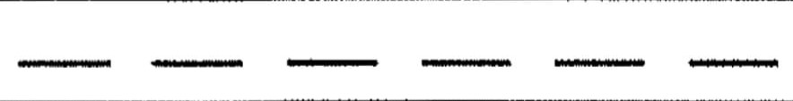

1. **Centre Lines:**

Centre lines are long dashed dotted lines, used to draw centre lines of circles.

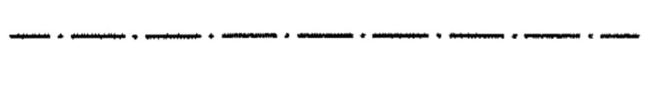

**PROCEDURE:**

1. Draw borders of the page and then make a title box with continuous lines.
2. Divide the page into four portion according to the dimensions of the object. The formula for space left (x) is given as;
$$x=\frac{Total length of page-sum of dimension of both views on that side}{3}$$

3. Make a grid.
4. Make layers for continuous, hidden and centre lines.
5. Now draw the visible edges of the drawing in the portions of the grid according to first angle of projection by continuous lines. For making the curved corners use fillet feature.
6. Trim the unusual or extra lines.
7. After drawing visible edges, draw the hidden features using hidden lines.
8. Now draw the centre lines of circles by using centre lines.
9. Now do dimensioning of the drawing.

**Drawing 01:**

**C:\Users\A.C\Downloads\1.dwg**

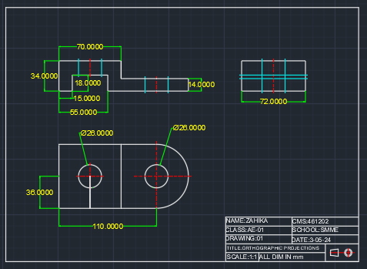

**Drawing 02:**

**C:\Users\A.C\Downloads\2.dwg**

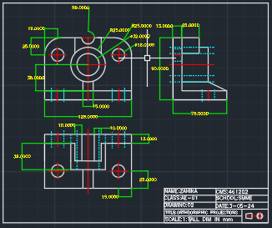

**Drawing 03:**

**C:\Users\A.C\Downloads\3.dwg**

